**Name: Kaushal Patel**

**12/1/2017**

**CMPEN 271**

**HW# 10**

**MOD-60 BCD counter**

Design and simulate MOD 60 (00 – 59) BCD counter that could be used in a DIGITAL CLOCK to display the minutes only (do not do the hours). Use two, 74163 MSI counters in the solution. Assume the input is a clock of frequency = 1 ppm (one pulse per minute). Show and clearly label all important timing diagram features (example: before and after key resets) with annotations and labels.

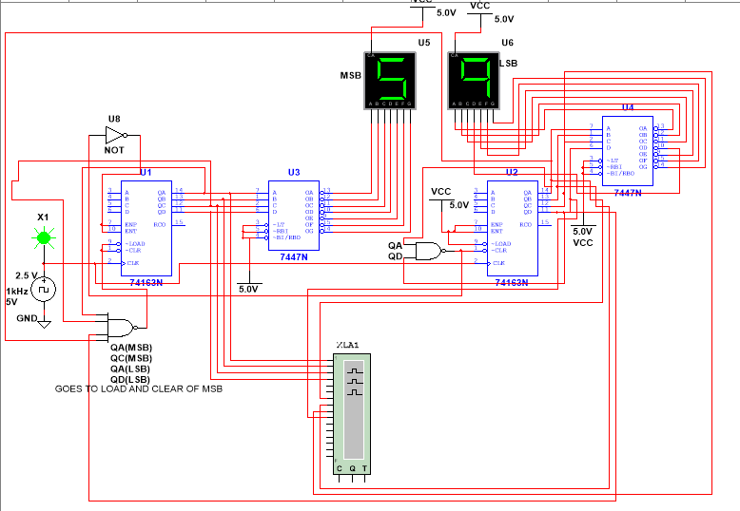**Circuit**:

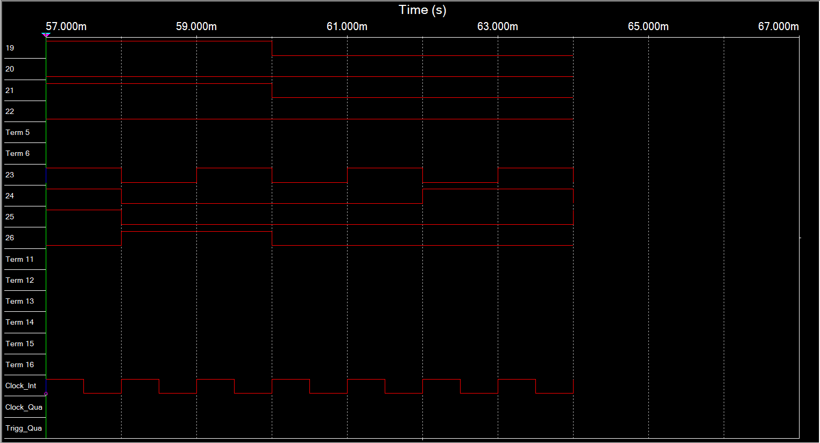**Logic Analyzer:**

A(LSB)

B

C

D(LSB)

A(LSB)

B

C

D(LSB)

MSB

LSB

(57)

(58)

(59)

(3)

(2)

(1)

(0)

Clock